Avame VisualStudio avame “DatabaseTask.Core” ja siis “Domain” sellese mappi lisame 4 classi: Employee, ConstructionCompany, Project, Specialist.

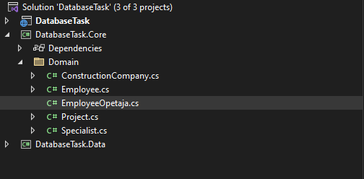

Lisame igasse loodud classi andmetüübid:

Employee:

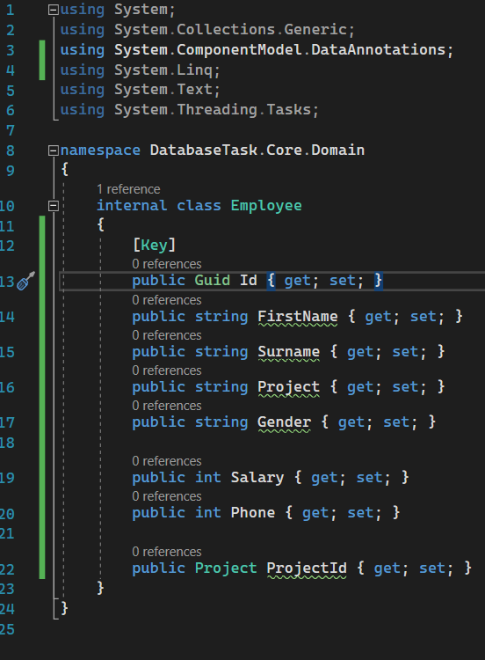

Project:

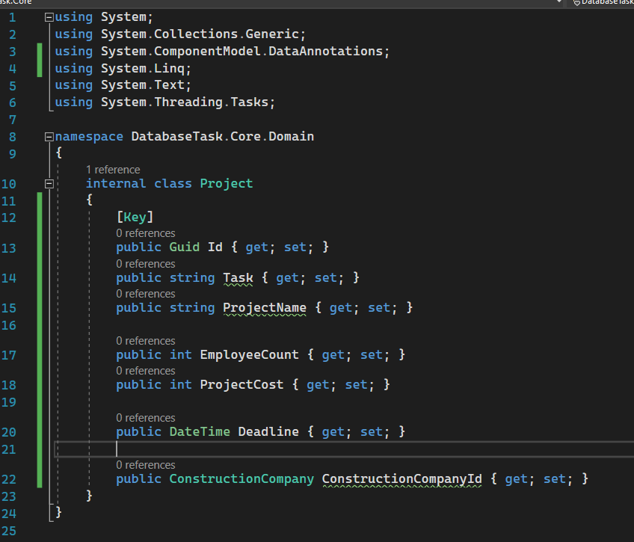

Specialist:

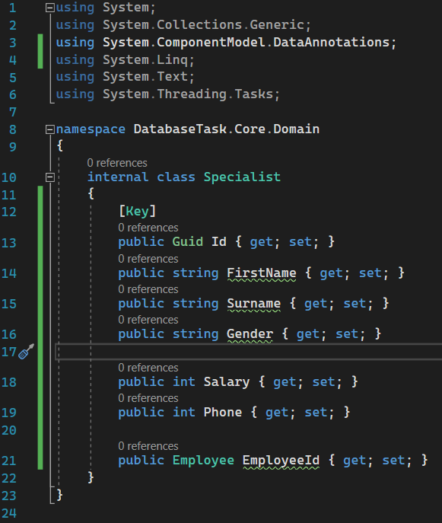

ConstructionCompany:

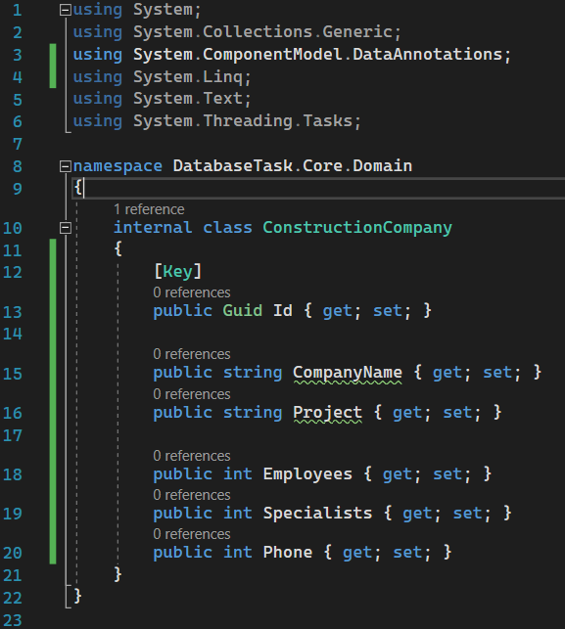

Siis teeme “add-migration “

Avame “Tools” - “NuGet Package Manager” - “Package Manager Console”

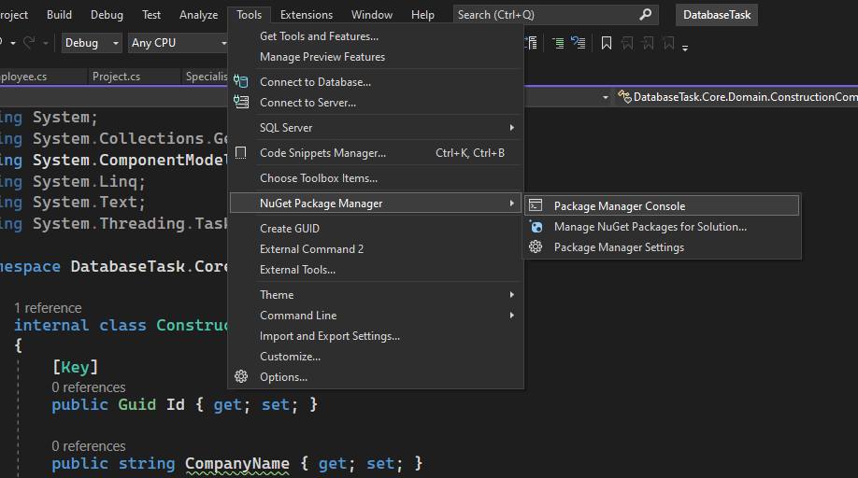

Ja kirjutame konsooli “add-migration” Name: Work

Peale seda update-database ja valmis.

**SQL:**

**--Procedure**

**--Employee**

create PROCEDURE spFilterBySalary

AS

SELECT * FROM Employee

insert into Employee values(newid(), 'Ivan', 'Makarov', 'Alpha', 'M', 1300, 237424, '75C81EE5-DDC9-4752-BF53-38023AF30801')

insert into Employee values(newid(), 'Soap', 'Mactavish', 'Gamma', 'M', 1350, 2374275, '9F78160C-350F-4765-B482-7484F6820066')

insert into Employee values(newid(), 'Simon', 'Unknown', 'Gamma', 'F', 1100, 237273, '9F78160C-350F-4765-B482-7484F6820066')

insert into Employee values(newid(), 'Hannes', 'Malter', 'Alpha', 'M', 1500, 2374279, '75C81EE5-DDC9-4752-BF53-38023AF30801')

insert into Employee values(newid(), 'Hannes', 'Plado', 'Beta', 'F', 700, 235274, '7DF77B6A-FB5D-4482-A113-A4C6E9924841')

insert into Employee values(newid(), 'Karl', 'Umbs', 'Alpha', 'F', 1050, 2674274, '75C81EE5-DDC9-4752-BF53-38023AF30801')

insert into Employee values(newid(), 'Darren', 'Uusküla', 'Beta', 'F', 1250, 354274, '7DF77B6A-FB5D-4482-A113-A4C6E9924841')

declare @SalaryOutput int

execute spFilterBySalary 1350, @SalaryOutput output

print @SalaryOutput

**--Construction company**

insert into ConstructionCompany values(newid(),'GigaChadCorporation', 'Alpha', 5, 2, 354274)

insert into ConstructionCompany values(newid(),'GigaCorporation', 'Beta', 3, 4, 957274)

insert into ConstructionCompany values(newid(),'ChadCorporation', 'Gamma', 7, 3, 754274)

SELECT * FROM ConstructionCompany

**--Project**

insert into Project values(newid(),'Hotel', 'Alpha', 7, 100000, '2027-05-14', '8CA91FD8-841A-4065-9A90-EA7C80D08667')

insert into Project values(newid(),'HotelPools', 'Beta', 7, 300000, '2027-05-14', '19DC6E15-4EC1-4001-A842-871366821328')

insert into Project values(newid(),'HotelDecor', 'Gamma', 7, 1000000, '2027-05-14', '96F96F95-AF64-46E7-82E7-2D18D2CE59CD')

SELECT * FROM Project

**--Specialist**

insert into Specialist values(newid(),'Jacob', 'Smonarh', 'M', 5650, 354274, '75C81EE5-DDC9-4752-BF53-38023AF30801')

insert into Specialist values(newid(),'Billy', 'Bob', 'M', 7650, 764274, '75C81EE5-DDC9-4752-BF53-38023AF30801')

insert into Specialist values(newid(),'Nes', 'Quick', 'F', 8350, 353874, '7DF77B6A-FB5D-4482-A113-A4C6E9924841')

insert into Specialist values(newid(),'Icewallow', 'Come', 'M', 6854, 354274, '7DF77B6A-FB5D-4482-A113-A4C6E9924841')

insert into Specialist values(newid(),'Dickin', 'Son', 'M', 5689, 354274, '7DF77B6A-FB5D-4482-A113-A4C6E9924841')

insert into Specialist values(newid(),'Mike', 'Hawk', 'M', 9645, 354274, '7DF77B6A-FB5D-4482-A113-A4C6E9924841')

insert into Specialist values(newid(),'Sugondese', 'Nuts', 'M', 5650, 354274, '9F78160C-350F-4765-B482-7484F6820066')

insert into Specialist values(newid(),'Luka', 'Tim', 'M', 3840, 354274, '9F78160C-350F-4765-B482-7484F6820066')

insert into Specialist values(newid(),'Jhonny', 'Since', 'M', 10050, 354274, '9F78160C-350F-4765-B482-7484F6820066')

SELECT * FROM Specialist

**--1 JOIN**

if COL_LENGTH('dbo.EmployeesBackup', 'Id') Is Null

begin

select Salary, ProjectName, Task

from Project

inner join Employee

on Project.Id = Employee.ProjectKeyId

end

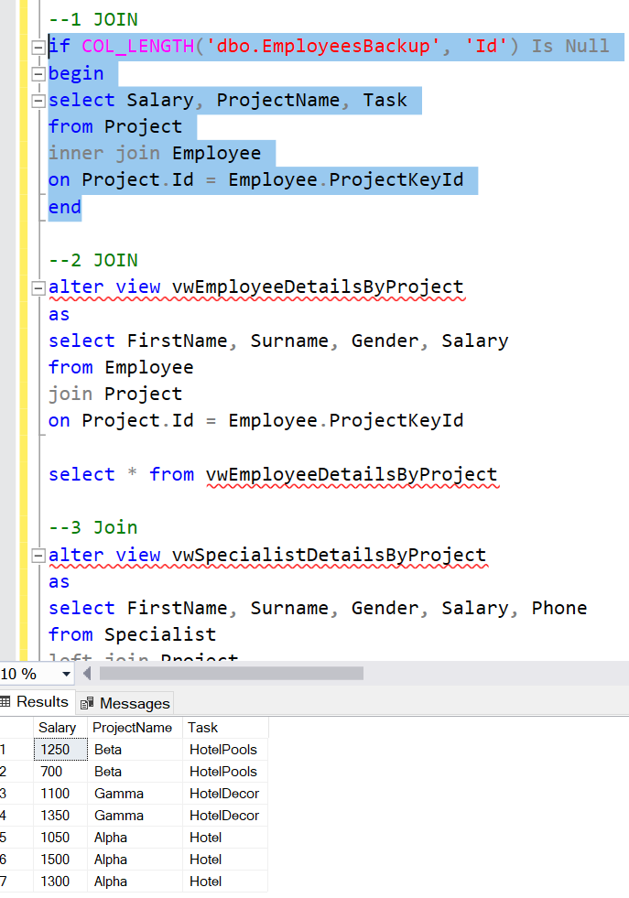

**--2 JOIN**

alter view vwEmployeeDetailsByProject

as

select FirstName, Surname, Gender, Salary

from Employee

join Project

on Project.Id = Employee.ProjectKeyId

select * from vwEmployeeDetailsByProject

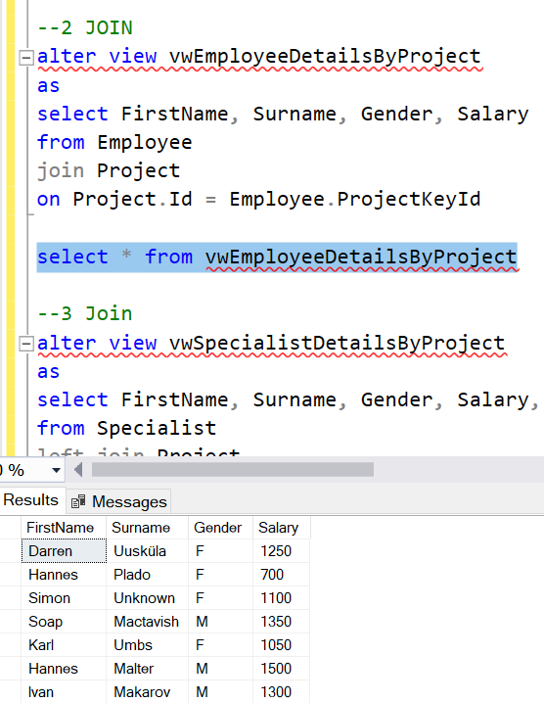

**--3 Join**

alter view vwSpecialistDetailsByProject

as

select FirstName, Surname, Gender, Salary, Phone

from Specialist

left join Project

on Project.Id = Specialist.ProjectKeyId

select * from vwSpecialistDetailsByProject

